Lead Generation Process

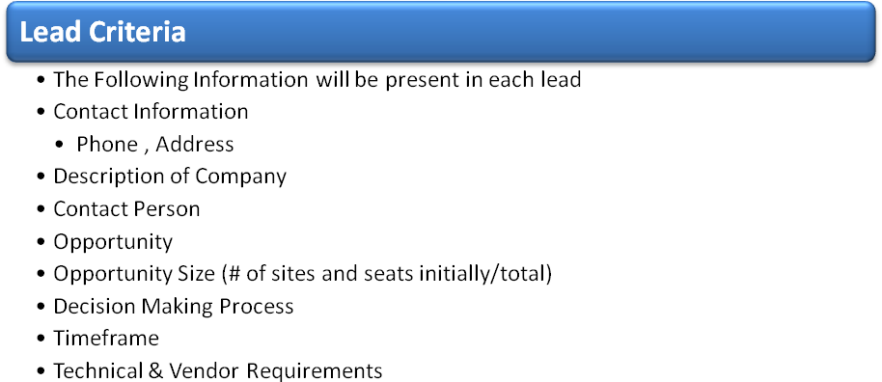
Lead Classifications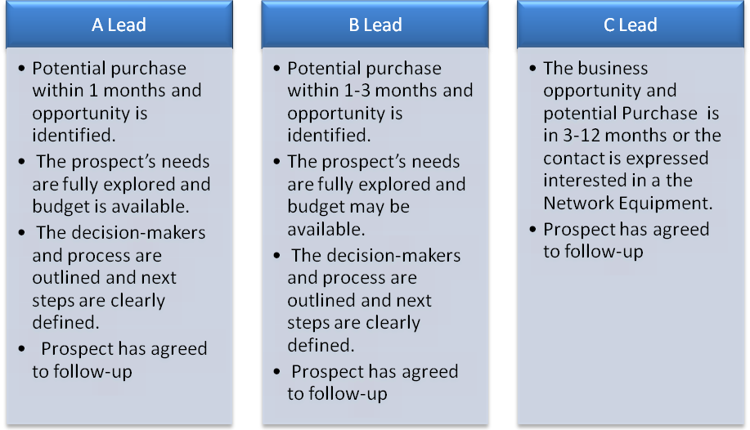

Call Process

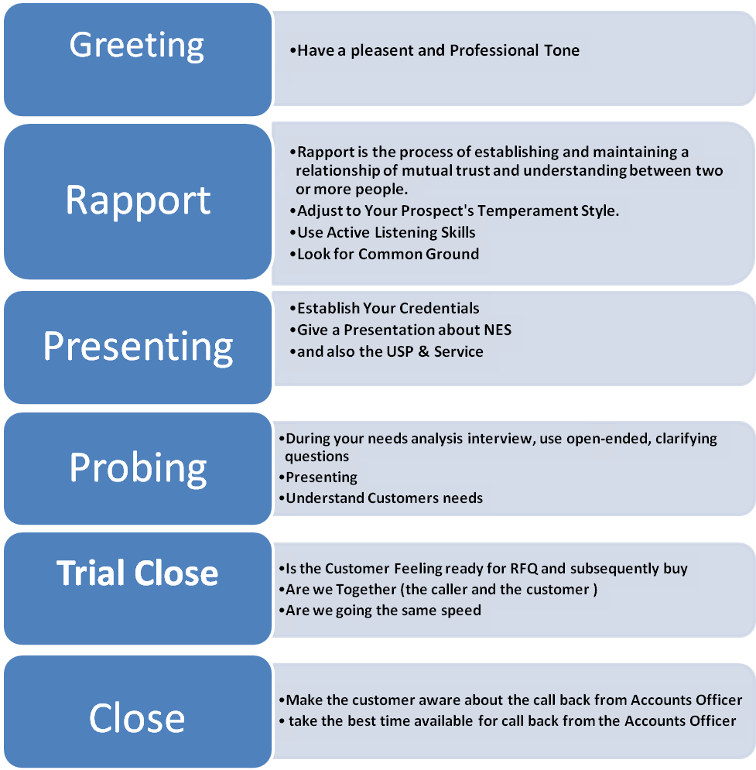

Probing Questions

Company Info
- How many Employees work in the Company?
- What is a area of operation of your company?

Network Info
- What Network Equipment do you use in your Network?
- What types of Servers do you have in your Network?
- What does your current communications environment look like?
SWITCHES/ROUTERS
- Are you looking to replace any of your current switches? What do you currently have in place?
- Do you have Cisco routers installed today?
How many remote sites do you have?
- How many remote sites do you have?
- Are they all supported by the same system?
- How much would you estimate you spend on moves, adds, and changes each month?
- Roughly how big is your telecom staff?
- How much would you estimate you spend on LD calls each month?
- How do you conduct moves, adds, and changes at your remote sites?
Do you have a PBX? Is it older than 2 years?
- What PBX technology currently drives your voice system?
- How do you finance your equipment? Where are you in terms of lease?
- How much would you estimate you spend on moves, adds, and changes each month?
- How much do you spend on maintained each month?

Reports

Lead Report
Each Lead will atleast have
- Company Name
- Phone number
- Address
- Contact Person
- Purchase Period
- Network Equipment Interested

Daily report
Number of calls made
Number of Leads
Remarks

Weekly Report
Consolidation of the Weekly activity presented a day before the Weekly meeting

